“The press must be free from state interference. It must enjoy the protection of the Constitution so that it can protect our rights as citizens. A critical independent investigative press is the lifeblood of any democracy.” – Nelson Mandela February 1994

2018 Daniel Pearl Peace through Music
Concert Hits a High Note in its Fifth Production
Thank you to everyone who contributed to making our fifth Sister Cities peace concert an evening that overflowed with both its talents and blended genres. The diversity of the program was symbolic of how music unites us no matter which city, country or continent we live in. The words, music and song spoke to the universal desire for a peaceful world where people of different races, religions and beliefs can co-exist. We thank everyone who attended to pay tribute to the ideals that Daniel Pearl stood for while alive, and of course, his love of music. We especially want to acknowledge each of the performing groups and individuals that shared their talents and love of community at the Basilica Shrine of Saint Mary on October 21:
Clyde Edgerton, Wilmington, NC Author, musician & artist,teaches creative writing at UNCW Contact info: www.clydeedgerton.com&Stephanie Perrin, country vocalist, was the other half of the duo
Babs McDance Studio, Wilmington NC – Choreography/dancers: Lindsey Fox & Samantha Bryson Contact info:www.babsmcdance.com

Staghorn StarlingsWilmington, NC – Country/folk duo Molly & Ozzie Darden. Contact info: https://www.facebook.com/StaghornStarlings/
Lesa Rogers Broadhead Wilmington, NC –Choreographer& dancer,Lesa is presently teaching at DREAMS of Wilmington, Wilmington Conservatory of Fine Arts & Brunswick Community College.
Marva Robinson&Tirah Phillips, Leland, NC,Lyric Soprano; Steve Young & George Miles, accompanist, Wilmington, NC
B’Nai Israel Kava Notes – Thom Clemmons, Music Director; David Burns, accompanist.Vocalists: Rabbi Robert Waxman, Alan Mandelstam, Arlene Burns, Beverly Schoninger, Elaine Lathrop, Jack Markowitz, Jim Liberman, Peggy PancoeRosoff, Sharyn Rosenberg, Shirley Levine, and Stephen Glaser. Contact info: www.facebook.com/Bnai-Israel-Synagogue
(Rabbi Emeritus) Rabbi James Apple, Temple of Israel, Wilmington, NC Contact info: www.temple-of-israel.org
DanijelaZezekl-Gualdi, violin, Wilmington, NC Contact info:gualdid@uncw.edu
Elizabeth Loparits, piano, Wilmington, NC Contact info: loparitse@uncw.edu
Scott Nunn, Star News, Wilmington, NC - opinions@starnewsonline.com
UNC-WilmingtonSeabelles – Wilmington, NC All women a Capella group. Vocalists: Maddie Mac Phail, Marianne Valino, Hanna Wickes, Krystal Apke, Sarah Ashbacher, Katerina Katsikis, Sarah Morrison, Angela Cotton, Alllison Boggs, Grace Vosburgh, Olivia Sommers, Olivia Williamson, Lauren Jaski, Alexis Jessup, Lindsey Aubuchon, & Marissa Vargas. Contact info: uncwilmingtonseabelles@gmail.com
Julia Walker Jewell, Wilmington, NC Music Director “Ode to Joy” Contact info: www.facebook.com/julia.w.jewell www.tedsfun.com
Mayor Pro-Tem Margaret Haynes
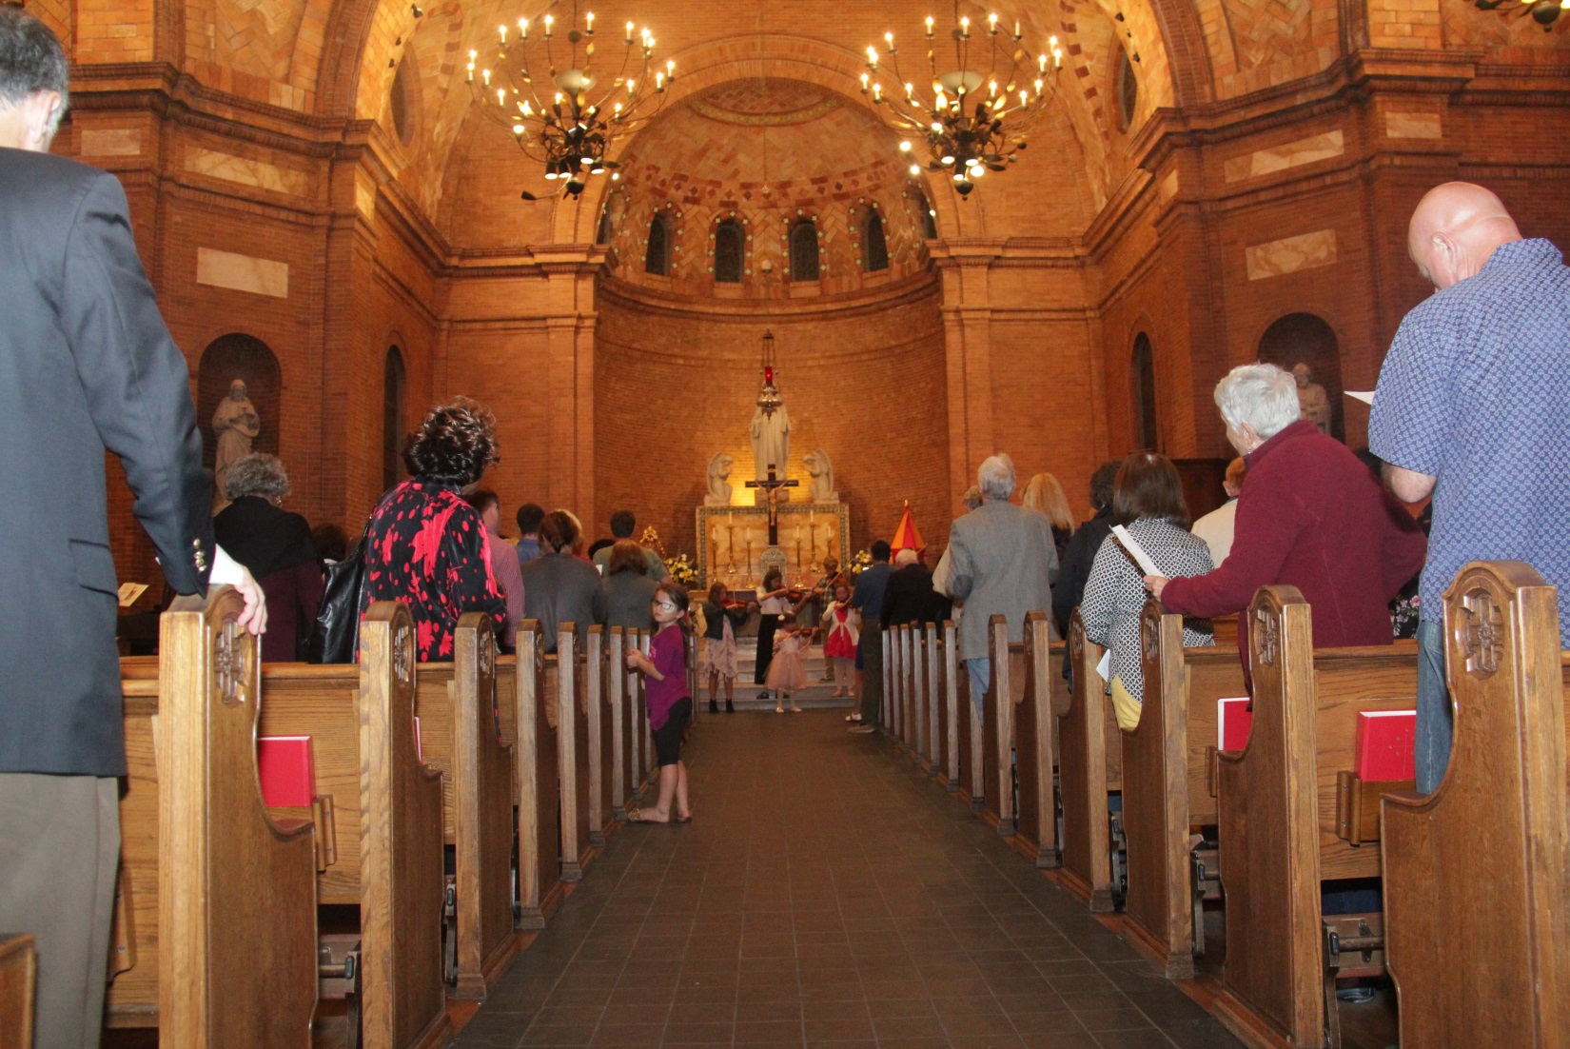
Special thanks go to our host the Basilica Shrine of Saint Mary and the steering committee members: Sara Bryant, Marilyn Cantarella, Julia Walker Jewell, Josh Rammel, Suzanne Smithand Lorraine Westermark who worked all year to design a program that would be memorable to participants and audience alike. Kudos to Clyde Edgerton ,who served both as emcee and performer, and stood out in his dual role. Official concert photographer, Owen Wexler, memorialized the evening, and Patrick Shovlin, CFCC Theater Major and stage manager, had the challenging task of coordinating each performance.Carter Jewell capably stepped in and assumed the lead role in Julia’s absence in the evening’s finale, “Ode to Joy.” To all we are deeply grateful for their contributions and community caring.
The program included a print memorial of the eighty-six journalists, photographers and broadcasters who died in 2017-18 while doing their job, without which basic human rights and the benefits of living in a free democracy would not be possible. Only the names of those whose deaths have been investigated and confirmed by the Committee to Protect Journalists were included in the Journalists Memorial. Scott Nunn, senior editor with the Star News, spoke to the perils journalists face in performing their jobs.

